CSCE 5222 Feature Engineering

Project Plan/Report

Group NUMBER 9

Member: **John Lage, Phongsiri Nirachornkul, Ibrahim Alkuwaifi**

1. Problem statement

*Clearly state the project you want to work on.*   
Our project is [**Detect the roads**](https://towardsdatascience.com/finding-land-area-of-farm-plots-using-edge-detection-5b070cc05c5a)and field boundaries

This project notes the different line features in the images to identify it as the roads, canels, or trails. Some of them are roads, but many are not roads or field boundaries which is a really challenging project. We can use this project to contribute to the GPS company to draw the road from the ground truth images, or to identify the boundary of the road for the autonomous car.

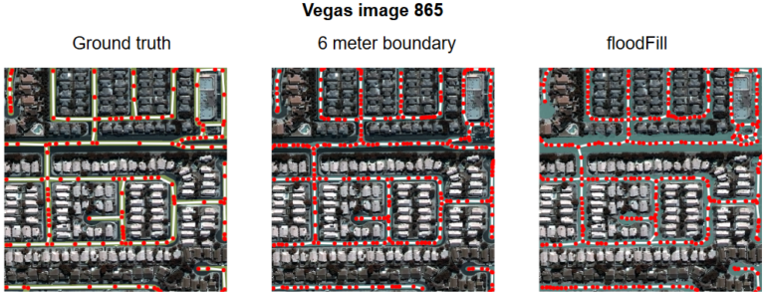

Cite : [nvdia](https://developer.nvidia.com/blog/solving-spacenet-road-detection-challenge-deep-learning/)

1. Data used

State the data used in this project including ground truth for evaluation

The image will be

1. Method

Give details of the method and any parameters used.

1. Convert to grayscale image in order to perform the test of the edge detection in each category.
   1. Apply Sobel filter - this filter will do a gradient verify at each pixel across an image. It is one of built-in matlab functions that performs an operation in both the horizontal and vertical direction and combines the results.
   2. Apply Canny filter - this filter will reduce the noise and the amount of data to be processed which will reduce a lot of false edges in the image. The detection will accurately catch the edge in the image concisely.
   3. Apply Laplacian of Gaussian - this filter is great for a big image because it can capture a tiny detail in the image, such as road, and the field boundaries. This filter will maximize the number of roads, and reduce the number of noise in the image greatly.

Citation for this project : [Toward Data Science](https://towardsdatascience.com/finding-land-area-of-farm-plots-using-edge-detection-5b070cc05c5a)

1. Evaluation

State the evaluation metric and discuss the results

The following are examples of inserting tables and figures. You can duplicate them and make changes for yours.

Table 1 This is an example of a table

| Name | Size | Type | Class | Accuracy | Precision |
| --- | --- | --- | --- | --- | --- |
| Image 1 |  |  |  |  |  |
| Image 2 |  |  |  |  |  |

